Type of Meeting | : | OB/CC Meeting
Date | : | 30 January 2021 | Next Meeting
Time | : | 2 pm (UTC +8) | Date | :
Place | : | Zoom Conference Meeting | Time | :
Notes by | : | CHM | Place | :

Present
President | Rita Soh (RS)
Vice President Zone A | Lalichan Zacharias (LZ)
Vice President Zone B | Saifuddin Ahmad (SA)
Vice President Zone C | Wu Jiang (WJ)
President-Elect | Abu Ahmed (AA)
Imm. Past President | Jahangir S.M. Khan (JK)
Hon Secretary | Chan Hui Min (CHM)
Hon Treasurer | Lin Hong Sui (LHS)
Advisor | Tan Pei Ing (TPI)
Chair (ACAE) | Gyanendra Shekhawat (GS)
Chair (ACSR) | Russell Dandeniya (RD)
Chair (ACGSA) | Acharawan Chutarat (AC)
Chair (ACYA) | Ridha Razak (RR)
Chair (Fellowship) | Qazi Arif (QA)
By Invitation
Observers
Tongji University | Zhou Ming Hao (ZMH)
Deputy Chair (ACPP) | Mukul Goyal (MG)

Absent with apologies
Advisor | Kun Chang Yi (KCY)
Chair (ACPP) | Dilip Chatterjee (DC)

ADOPTION OF MINUTES from last meeting
The minutes of the 11th ARCASIA OB/CC meeting were adopted as proposed by GS and seconded by RD.

treasurer’s update

Bank Account

Process of fund transfer from PAM-ARCASIA account in progress

Invoices to member institutes issued, in process of tracking

2020 Accounts to be prepared. Awards accounts to be consolidated. Tabulate major cost items to be reported to Council

Prize money to be awarded to Student Competition winners

RS reported that AEA accounts also need to be reconciled with ARCASIA accounts

LHS to set up separate meeting with AEA on accounts.

Special programs for 2020 across committees

ARCASIA Integrated program

The committee chairs updated the program as below:

2021
Jan 16 | ACAE | ACAE Student Competition Results announcement event
Jan 23 | Fellowship | Webinar - Reflection on 50 years of ARCASIA
Jan 30 |  | OB Meeting
Feb 14 | ACAE | ARCASIA Student Competition Acknowledgement
Feb 20 |  | OB Meeting
Feb 27 |  | Interim Special Council meeting
Mar 6 | ACAE | TOY Awards presentation, E-book launch
Mar 27 | Fellowship | Remembering Djuhara
Apr 9-10 | ACAE | Teachers Training module – Online Training Workshop
May | ACAE/ACPP/ACGSA | Collaborative Panel Discussion with ACPP and ACGSA
May | ACSR | Virtual round table
June | ACAE | Architectural Studio Design – Design session for Students & Lecturers
July 7-10 | ACAE | Co-event with International Architectural Education Conference
Aug | ACPP/ACYA | IT Adoption
October | ACAE | Co-event with International Courtyard Symposium Melaka

ACAE

Preliminary program has an event organised each month until June 2021, anticipating online activities at least to

RS Request more engagement with Zone C

ACPP

RS suggested engagement with ACYA for software

4 events

ACPP/ACYA July

ACGSA

RS recommended that ACGSA go beyond green rating tools to incorporate UN SDG and Wellness issues in the topics for webinars.

ACSR

COVID guidelines to be launched during Interim Council meeting on 27 Feb.

RS gave direction for the guideline documents to be published and distributed as a normal ARCASIA publication. Since the guidelines should be further adapted to the context of each country and ARCASIA cannot oblige the member institutes to adopt the recommendations, there is no need to create an ARCASIA resolution or charter.

Report of conference on Urbanism

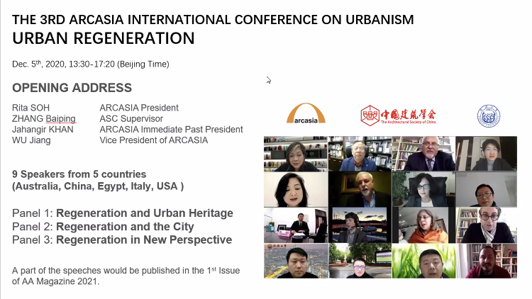

agenda for CounCIL Meeting

President’s welcome

Member institute update (no slides) (60 min)

Summary of Activities in 2020 and plans for 2021 (20 min)

ACA19 program and format (20 min)

Forum20 hosting discussion (20 min)

Changes in Student competition guidelines to standardise prizes

Changes in guidelines to include TOY

Launch of publications (5 min)

COVID-19 Guidelines

Student Competition E-book

TOY E-book

Launch of AA Magazine (1 min)

Networking time (15 min)

preliminary plans for 2021

2021 context, Committee plans

Transition plan to next OB

AA suggested that Deputy Chairs and the upcoming Hon Treasurer, Hon Sec to be observers of OB meetings in later half of 2021

AA informed the meeting that the new Hon Treasurer and Hon Secretary shall be appointed by 6/2021

update on architecture asia magazine

Contract review and acceptance

OB reviewed the suggested changes to the AA Magazine contract.

RS accepted the inclusion of an arbitration clause but requested that the arbitration venues include Singapore.

Update of progress

Web portal to be launched in Feb

2 issues

KAU (DPRk) joining ARCASIA

ARCASIA foundation

Barry Will Prize

Proposed meeting dates with Joseph Kwan 2 Feb

ACA19 Update

Program

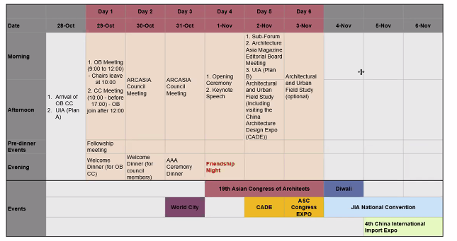

Concerns by ASC

Hybrid conference may be a reality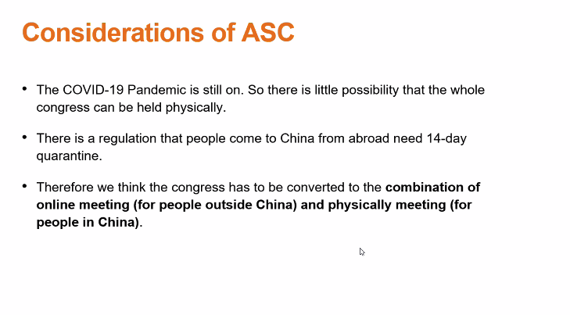

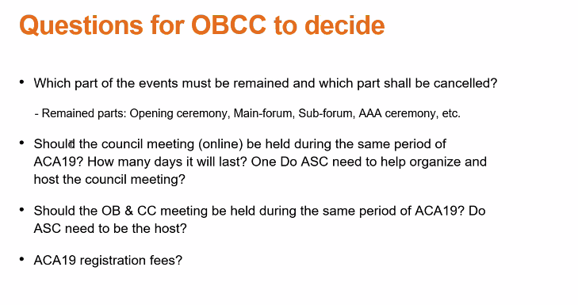

OB does not object to ASC’s proposal to organise a hybrid format

CHM suggested that the cost of the hybrid format should still be taken up by ASC

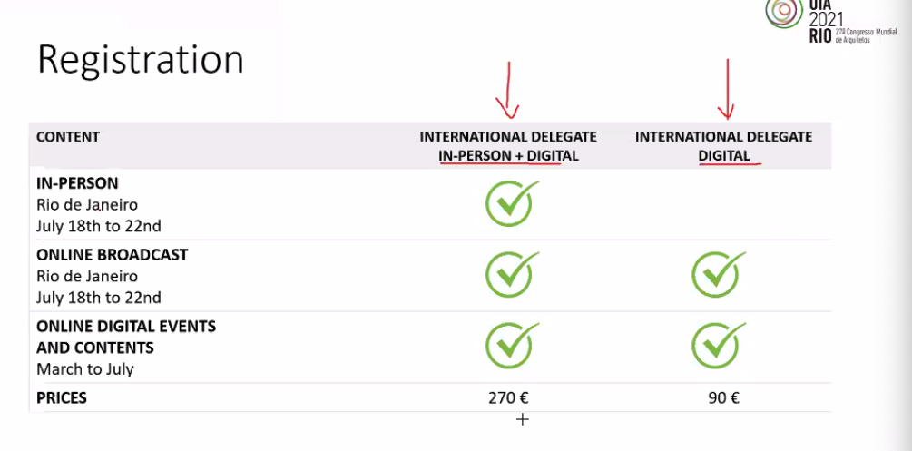

Adopting guideline to accept online meetings as valid as physical

Identify framework

To be presented at 27 Feb Council

OB meeting 20 Feb to deliberate on ACA19

AAA update

Analysis of Participation

Analysis of AAA 2020 results

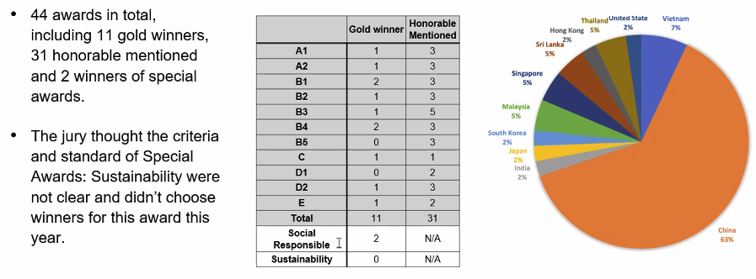

Preparation for AAA 2021

The convenor for AAA 2021 will be WJ

WJ requested meeting to discuss

improve AAA submission process and portal

Criteria of Special Award: Sustainability

Urbanism

Schedule of AAA 2021

RS suggested to the convenor to include urban design and urbanism.

CHM highlighted that the awards is open only to registered architects, the best urban solutions may not be produced by architects.

JS, RS and TPI felt that there is still scope to claim the space for architects and that an urban design category for the AAA may be a way to promote this.

AC highlighted that ACGSA can propose the criteria sustainability.

CHM suggested using the UN SDG as criteria for sustainability and social responsibility.

GS to draft a letter for RS to request ASC to host TOY, and make a request for new guideline to standardise prizes

ARCASIA Sponsorship guidelines

AOB

Forum 20

CHM

ACTION TRACKING LIST
 | Item | Owner | Deadline
1 | Council Paper for revision of Student competition Guidelines to standardise prizes | GS | Next council meeting
2 | Evaluation of KAU joining ARCASIA | CHM/TPI | Next council meeting
3 | Discuss revision of Barry Will Prize with Barry Will Estate/HKIA | RS/RR | End 2020
4 | 50th Anniversary book printed edition | WJ | Next council meeting
5 | Committee Chair Letter to President | All Committee Chairs | 1st Week of December
6 | President’s Letter to Member institutes | RS/CHM | 2nd Week of December
7 | Invoice for collection of Membership fees | LHS | December
8 | COVID-19 Guideline Charter creation | RD | End Dec 2020
9 | Update of Sponsorship guidelines | CHM/TPI | Next OB Meeting
10 | Update of ACA19 plans | WJ | Next OB Meeting
11 | Report on AA Awards | WJ | Next OB Meeting

