Type of Meeting | : | OB/CC Meeting
Date | : | 29 May 2021 | Next Meeting
Time | : | 2 pm (UTC +8) | Date | :
Place | : | Zoom Conference Meeting | Time | :
Notes by | : | CHM | Place | :

Present
President | Rita Soh (RS)
President-Elect | Abu Ahmed (AA)
Vice President Zone A | Lalichan Zacharias (LZ)
Vice President Zone B | Saifuddin Ahmad (SA)
Vice President Zone C | Wu Jiang (WJ)
Imm. Past President | Jahangir S.M. Khan (JK)
Hon Secretary | Chan Hui Min (CHM)
Hon Treasurer | Lin Hong Sui (LHS)
Advisor | Tan Pei Ing (TPI)
Chair (ACAE) | Gyanendra Shekhawat (GS)
Chair (ACPP) | Dilip Chatterjee (DC)
Chair (ACGSA) | Acharawan Chutarat (AC)
Chair (ACSR) | Russell Dandeniya (RD)
Chair (ACYA) | Ridha Razak (RR)
Chair (Fellowship) | Qazi Arif (QA)
By Invitation
Observers
Tongji University | Zhou Ming Hao (ZMH)

Absent with apologies
Advisor | Kun Chang Yi (KCY)

Forum 21 Country bid update
Continue to pursue updated presentation. If none are forthcoming, proceed to circulate the presentations already in hand to the Council
Ideally, the Council decision should be completed by end July to allow the host institute to prepare for Forum 21 accordingly.

ACA19 Update

ACA19 Website

Website soft-launched on 15 March

Forms and website to feature ARCASIA Logo more prominently

Student competition and TOY

Exhibit at least the winners, convenor to decide whether to exibit the rest

Student Jamboree

Theme: Reconnecting our community

Date: 29-31 October 2021

Venue: Shanghai (+ online)

Format: Each member institute need to select 5-10 students composing as a team for student jamboree teamwork, each team is composed with 1 tutor decided by each member institute.

ACA19 will provide an online platform for participants to join individually without the need to gather physically.

Quota of 10 students per institute.

ACAE will meet with ACA19 to coordinate logistics and present at the next OB-CC meeting.

Barry Will award

CHM will connect ACA19 to Frankie to coordinate the award logistics

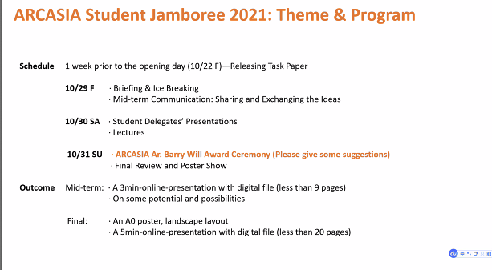
ARCASIA STUDENTS’ ARCHITECTURAL DESIGN COMPETITION 2021
PANEL OF JUROR
ACAE Chairman (Head Juror) Competition Convener Representative from Zone A Representative from Zone B Representative from Zone C
Ar Gyanendra Singh Shekhawat (IIA) .......................................................
Ar M. Arefeen Ibrahim (IAB)
Ar CK Lim (SIA)
Ar Inbum KIM (KIRA)
ARCASIA THESIS OF THE YEAR AWARDS 2021
PANEL OF JUROR
ACAE Immediate Past Chairman (Head Juror)
ACAE Chairman
Convener of ARCASIA Students Architectural Design Competition .................................................
ARCASIA President’s Nominee Representative from Zone A Representative from Zone B Representative from Zone C
...............................................
Ar Khadija Jamal Shaban (IAP) Ar Jonathan V Manalad (UAP) Prof Kaname Yanagisawa (JIA)

_{Stu}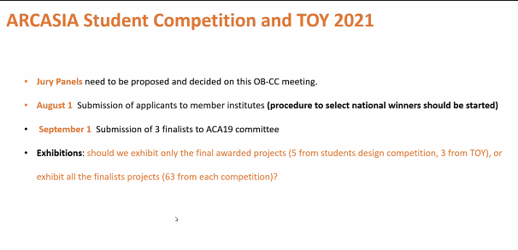

Registration will commence June 30

Theme: Sharing & Regeneration

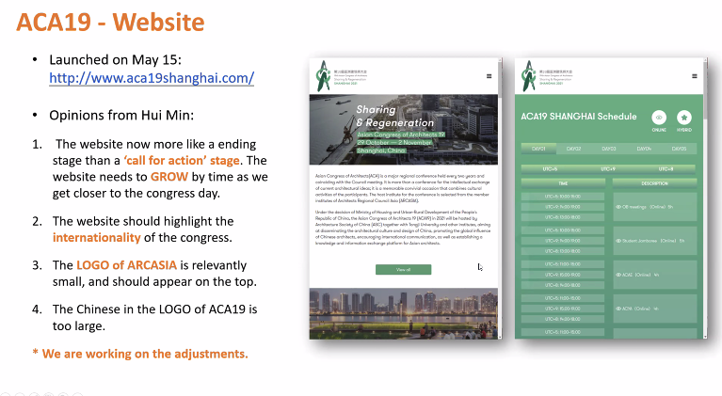

AAA 2021 update

WJ reported that there were 231 submissions and the validation of the eligibility and materials will be completed by 19 June. The jury will commence shortlisting the entries by 27 June.

The Jury has been finalized and the official invitations will be sent by next week.

Rita Soh President of ARCASIA and Zone B

Jitendra Singh, Architect from Zone A

Shiling Zheng, Architect from Zone C

Francesco Dal Co, International architect

Kenya Hara, Non-architect

The jury panel will be announced on the ACA19 and ARCASIA websites in early June

Joint Committees’ webinar

Council meeting agenda

KAU Member application

Application materials have been received.

Invitation to KAU to Council meeting, whether online or in person.

TPI and KC will run through the evaluation report and recommendation during the Council meeting

Council Resolution

Forum 21 – host institute to present update

Election platforms – electionbuddy.com

program for 2021 across committees

ARCASIA Integrated program

The committee chairs updated the program as below:

2021
Jan 16 | ACAE | ACAE Student Competition Results announcement event
Jan 23 | Fellowship/ACYA | Webinar - Reflection on 50 years of ARCASIA
Jan 27 | ACYA | ACYA meeting
Jan 30 |  | OB Meeting
Feb 14 | ACAE | ARCASIA Student Competition Acknowledgement
Feb 20 |  | OB Meeting
Feb 21 | ACYA | ACYA Instagram Challenge on pandemic living
Feb 27 |  | Interim Special Council meeting
Mar 6 | ACAE | TOY Awards presentation, E-book launch
Mar 20 |  | OB Meeting
Mar 20 | ACYA | ACYA Alumni Web Forum
Mar 27 | Fellowship | Remembering Ahmad Djuhara – Memorial Symposium
April 3 | ACGSA | ACGSA Webinar – The Evolution of Urban Resilience & Regeneration Futures with Nature
Apr 9-10 | ACAE | Teachers Training module – Online Training Workshop
Apr 24 |  | OB Meeting / Forum bid Presentation
May 29 | OB/CC Meeting
June 19 | ACAE | Architectural Studio Design – Design session for Students & Lecturers
June 19 | OB/CC Meeting | Including Deputy Chairs and new Hon Sec, Hon Treasurer
June 26 | ACYA | Launch E Sports Arena design competition
July 3 | ACGSA | ACGSA Competition winner announcement
July 7-10 | ACAE | Co-event with International Architectural Education Conference
July 17 |  | Joint Committee Event Dry Run
July 24 | Joint Committees Event | Minding our Heritage
Aug 14 | ACSR | Virtual Round table
Aug 15 | ACYA | ACYA Design Challenge E Sports Area final presentation
Aug 21 |  | Joint Committee Event Dry Run
Aug 28 | Joint Committees Event | Embracing Digitalisation
Sept 25 | Fellowship | Fellowship Talk – SDG & Architects Beyond Architecture
October | ACAE | Co-event with International Courtyard Symposium Melaka
Oct 29-Nov 3 |  | 41st Council Meeting and ACA19

The meeting ended at 4:40pm

ACTION TRACKING LIST
 | Item | Owner | Deadline
 | Evaluation of KAU joining ARCASIA | CHM/TPI | Next council meeting
 | 50th Anniversary book printed edition | WJ | Next council meeting
 | Update of Sponsorship guidelines | CHM/TPI | Next OB Meeting
 | Update of ACA19 plans | WJ | Next OB Meeting
 | Report on AA Awards | WJ | Next OB Meeting
 | AAA 2021 preparation | WJ
 | AAA Sustainability Evaluation Guidelines | AC
 | AAA Social Responsibility Evaluation Guidelines | RD
 | Follow up on Barry Will Award | RS, CHM
 | AEA action plan | TW
 | Follow up on AA Magazine contract execution | ZMH, CHM | Next OB meeting
 | Joint Committee Panel Discussion programme | ALL COMMITTEE CHAIRS | Next OB Meeting
 | Resolutions to all member institutes | CHM | Next OB meeting
 | Forum 21 Bid presentations | CHM | Next OB Meeting

New UAP president Armando Guzman (July)

