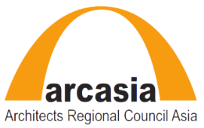
ACPP ARCASIA Committee on Professional Practice

ACPP PROGRAM FOR 2017-2018

The meeting discussed on the Proposed Program for year 2017 and 2018.

Tentative ACPP Program for 2017 & 2018 are as follows:

 | Tentative Date | Venue | Programme | Remarks | Action
1. | 23rd May 2017 | Jaipur, India | ACPP Committee Meeting |  | IIA
2. | 09th September 2017 | Seoul,  Korea | ACPP Meeting in conjunction with  UIA convention | Informal Meeting | KIRA
3. | 19th-20th January 2018 | Calcutta,  India | ACPP-IIA Professional Practice Forum “Architects Fee: Issues and Challenges”  ACPP Meeting | IIA Calcutta confirmed | IIA
4. | 08th-10th  April 2018 | Bandung, Indonesia | ACPP-IAI Professional Practice Forum/Roundtable | Confirmed | IAI
5. | 10th-14th September 2018 | Tokyo, Japan | ACPP 2018 Meeting | ACA,18 JAPAN | JIA
6. | 06th-07th December 2018 | Kuala Lumpur, Malaysia | ACPP – PAM  Professional Practice Forum  ACPP Meeting | Confirmed | PAM

Note:

1). ACPP-AUA Roundtable/Forum - date and venue to be confirmed
2). ACPP-ACE Roundtable - date and venue to be conformed

