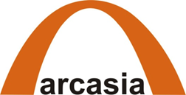

Arcasia Committee on Social Responsibility (ACSR)

with generous financial support of

- ARCASIA Corporate Partner

presents
"Universal Design"-Public Toilet for ALL or All
Design Ideas Competition Criteria
Kathmandu, Nepal
2013-07-29

BACKGROUND::
At a time when people around the world are awakening to Universal and Accessible Design as an important tool towards achieving human right through the enactment of the momentous UN Convention on the Rights of People with Disabilities (UN-CRPD). The sense of opportunity and real need for change is greater than ever. However, Nepal is still far behind in aspects related to Universal Design and Accessibility. The provision of equitable physical accessibility to public infrastructure for persons with disabilities is continuously being neglected. Having not even a single accessible public toilet in the heart of capital at Kathmandu that a wheelchair user could use is just one example of the dire situation in Nepal.
Nowadays, almost public and private buildings are being made without considering abilities, age and gender of the users. There are no activities to apply or to develop the inclusive design because there is a misconceived mindset that inclusive or universal design is expensive to implement. Whereas, providing products and built environments with universal design will enable more users to live independently and to be given equal opportunities to run their daily living activities. In turn, this effort will enhance productivity of the society and become a sustainable investment when the population ages.
In order to address these issues as part of the social responsibility and obligation pertaining to all Architects, the theme "Universal Design" - Public Toilet for All! was chosen for this design competition as it is a most important part of our professional life to be engage meaningfully in society in every aspects of life with-dignity.
Designers, educators and students are encouraged to work and function outside of their "comfort zone" or sphere of influence. It is the Competition Organizers intent to establish criteria that is mindful of human diversity and their needs
in addition to meeting aesthetics, function , economic value, and creativity the capability of designers will also be challenged by the designing process, in how to inclusively incorporate universal and accessible-design features resulting in cost-effective, appropriative and sustainable design solutions that promote positive image of disability in society.

THE PROJECT:

Architectural Design Competition- A One Stage Design Ideas Competition
The Design Competition will be held in two Categories:

- Student Category
- Professional Category

Theme of the design competition will be “Universal Design” - Public Toilets for All! The aim of this design competition is to educate students and the professionals
on the diverse needs of today’s society, to develop a comprehensive understanding on the issues relating to Universal Design and Accessibility, and to encourage and sensitize the professional architects to be more socially responsible in addressing and implementing accessibility with their professional knowledge, skill sets and creativity. The outcome of the design competition will help to create a National Standard in providing accessible toilets for all in Nepal. The design entries from the 10 winning finalists in each category will be displayed as part of an awareness campaign during and after the events.

For this design competition, students and professional will design a public toilet with in surrounding of any of three world heritage site of Nepal: Lalitpur, Kathmandu or Bhaktapur Durbar Square's Area where flow of travel of both local and foreign visitors is high. Each design team will choose one specific site within the selected designated zone which should be perfectly fit architecturally, socially, culturally and should aim to serve for majority local and foreign visitors of the particular world heritage site.

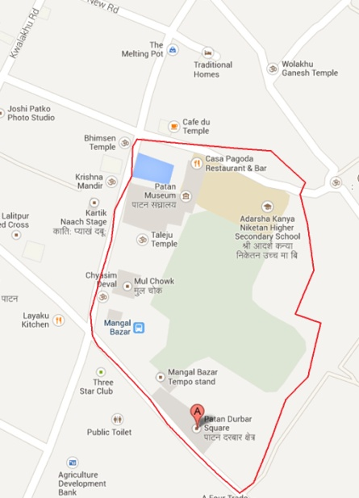 | 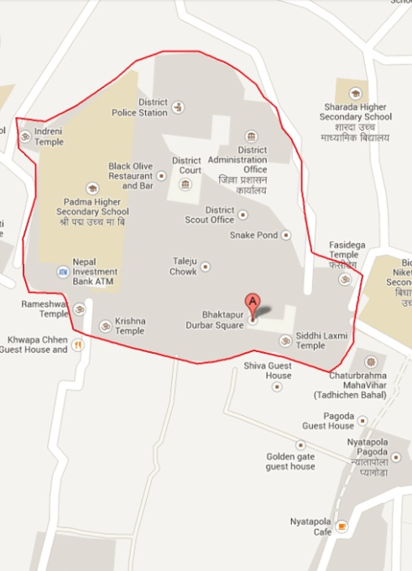 | 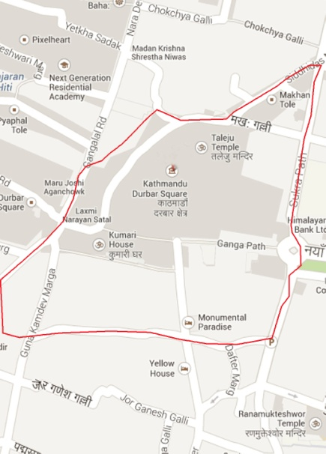
Fig (1) Site plan of Patan Durbar Sq. Fig (2) Site plan of Bhaktapur Durbar Sq. Fig (3) Kathmandu Durbar Sq.

The public toilet will be a single story facility for unisex use , approximately built-up area is 9m×13m square meter, - that could serve 16 people at the same time, with space for waiting and other activities . The design of the public toilet will take into account an interdisciplinary and inclusive approach to design that will incorporate overall user-centered, universal and environmental design principles that will include, but not be limited to architectural, graphic/visual communication, interior, landscape architecture and product design applications.

Design should incorporate the 7 principles of UNIVERSAL DESIGN
The Principles of Universal Design
“The design of products and environments to be usable by all people, to the greatest extent possible, without the need for adaptation or specialized design.”

Principle 1: Equitable Use: This principle focuses on providing equitable access for everyone in an integrated and dignified manner. It implies that the design is appealing to everyone and provides an equal level of safety for all users.

Principle 2: Flexibility in Use: This principle implies that the design of the house or product has been developed considering a wide range of individual preferences and abilities throughout the life cycle of the occupants.

Principle 3: Simple and Intuitive: The layout and design of the home and devices should be easy to understand, regardless of the user’s experience or cognitive ability. This principle requires that design elements be simple and work intuitively.

Principle 4: Perceptible Information :The provision of information using a combination of different modes, whether using visual, audible or tactile methods, will ensure that everyone is able to use the elements of the home safely and effectively. Principle 4 encourages the provision of information through all of our senses — sight, hearing and touch — when interacting with our home environment.
Principle 5: Tolerance for Error: This principle incorporates a tolerance for error, minimizing the potential for unintended results. This implies design considerations that include fail-safe features and gives thought to how all users may use the space or product safely.
Principle 6: Low Physical Effort: This principle deals with limiting the strength, stamina and dexterity required to access spaces or use controls and products.
Principle 7: Size and Space for Approach and Use: This principle focuses on the amount of room needed to access space, equipment and controls. This includes designing for the appropriate size and space so that all family members and visitors can safely reach, see and operate all elements of the home.
Source: www.centerforuniversaldesign.org

THE BASIC CRITERIA:

Public served: Public toilet facilities should provide for the needs of people of different cultural backgrounds and genders, all age groups, parents and children, people with disabilities( wheelchair users, the blind and low vision, the speech and hearing impaired) and their care givers.
Functionality: A public toilet should provide facilities for the public to urinate, defecate, clean themselves, groom and tend to other bodily needs in a secure, private and clean environment and should be functional at all times during normal hours of operation.
Signage: Public toilet facilities should be designed with a legible signage system of Universal Design for both genders. Signs should be readily visible and located near the entrance to each toilet facility and prominently displayed in main traffic passageways. Signs should be so designed as to utilize a commonly recognized international male and female ﬁgure along with the International Symbol of Access (ISA) in contrasting colors.
Durability: Public toilets and all its associated ﬁttings, valves, piping, accessories and ﬁxtures for such, should be designed to withstand the effects of the weather, external loads, heavy usage, abuse, vandalism, and other undesired activities. At the same time, the fittings must comply with the principles of Universal Design.
Lighting:
When utilizing natural light, the minimum net glazed area should not be less than 10 percent of the floor area of the room served. When utilizing artificial light, it should provide an average illumination of 100 lux (10 foot-candles) over the area of the room at a height of 750 millimeters (30 inches) above the floor. The use of natural light through skylights and wall opening are essential.

Ventilation:
Natural ventilation of an occupied space should be through wall and roof openings windows, doors, louvers or other openings to the outdoors. The operating mechanism for such openings should be provided with access so that the openings are controllable by the building occupants and securable in the event the public toilet rooms need to be secured from vandalism. If mechanically ventilated, the air exchange rate should have a minimum of 15 air changes per hour or 35.4 L/s (75 cfm) exhaust per toilet cubicle. The use of natural updrafts and cross ventilations should be adopted.

Interior Space:
Floors should be constructed with, nonslip surfaces such as ceramic tiles, natural stone, homogeneous tiles, terrazzo or other surfaces that are durable and easy to clean and maintain.

Accessible Unisex Toilet Cubicle for use by both genders should be provided with following requirements:
Access shall be provided directly from the outside or form a minimum 1500 mm wide public corridor; and not situated within the Male and Female Toilets. The access to the Cubicle must be level and without any steps or thresholds.

Internal Area of the cubicle shall be at least 1750 mm wide and 2300 mm long , and to accommodate the clear turning circle of one wheelchair to make a 360-degree turn. This clear turning circle space must be at least 60'' (1500 mm) in diameter.

Water Closet (WC) suite shall have a height not less than 380 mm and not more than 450 mm measured from the floor to the floor to the top of the toilet seat. The Water Closet (WC) shall be equipped with a back support such as a seat lid.

Flushing Control to the WC shall be mounted on the wide side of the Cubicle at a height between 600 mm to 1050 mm above the floor, and shall be hand-operated or automatic. Hand-operated controls shall be capable of being operated with one hand.

Wash Basin shall be provided within the Cubicle with the basin rim not higher that 750 mm above the floor. A clearance of 550 mm shall be maintained from the floor to the bottom of the apron to provided a clear and unobstructed approach of wheelchair users to reach the basin. The water tap for the wash basin shall be automatic or of lever -type handle.

Toilet Cubicle Door shall be installed with push-type or lever-type handles and capable of being easily opened and closed with one hand. Door lock or fastener shall be capable of being released from the outside in the event of an emergency.

Grab Rails shall be installed to assist wheelchair user transfers from their wheelchairs to the WC suite. There shall be at least two 600 mm long grab rails fixed to the wall and one 750 mm long foldable grab rail installed on the wide side of the WC suit at 750 mm above the floor. All grab rails shall have an external diameter between 32 mm to 40 mm, and capable of carrying a static of 150 kg.

Other Sanitary Fittings installed within the Cubicle, such as mirror, toilet paper dispenser, soap dispenser, hand dryer, coat hanger, etc shall be reachable and usable by a wheelchair user with design heights between 800 mm to 1200 mm.

Privacy: The design of the toilet should need to maintain privacy of each individual regardless of age, gender, ability and impairment.

Security and Vandalism Measures: During nonoperational hours, entry and exit doors and windows to public toilets should be secured by locks or dead bolts to discourage vandalism. The design should also address the provision to draw attention in case of emergency or accident.

NOTE: The above design criteria are provided for references only Participants are encourage to do research - to be informative , innovative and creative with own original solution to meet the context of Nepal.

SUBMITTAL CRITERIA:
Each submission must meet the following four criteria in all aspects of the design:
Universal Design/Design-for-All:
The design must be usable by a wide range of people across the spectrum of ability and age in the widest variety of circumstances without separate or special features.
Sustainable Design:
The design must incorporate practices and products that have long life and durability; that maximize the use of recyclable, reclaimed or salvaged products; that minimize the use of energy, including the energy and resources required to transport; and materials that enhance human health and well-being.
Appropriate and Low Cost:
The design must be possible to be constructed and finished with low-cost and appropriate construction materials, finishes and minimally skilled labor. Competitors should provide outline strategies for supplementing outlays of cash with donated goods and services.
Design Excellence:
The design must incorporate both visual and haptic (e.g., tactile, auditory) appeal appropriate to the cultural and physical context of Nepal.

SUBMITTAL REQUIREMENTS
Visual Documentation:
2 No of board each in 500 mm X 750 mm or 20 inch x 30 inch with diagrams, elevations, floor plans, sections with scale figures, renderings, photos of models, notations about materials, and details of some important feature. The registration number should be displayed on the top right-hand corner of submission board.
Written documentation:
- Description of the design process - 300 words, maximum.
- Description of the design - 300 words, maximum.
- Description of ways the proposal meets the four criteria - 300 words, maximum.
All entries shall be submitted electronically/digitally to: kcdeepak2003@yahoo.com, save as JPEG file at 300 dpi resolution. The Jury will review submission on-line. Those Competitors who are shortlisted are required to prepare presentation boards for the final jury adjudication.
No personal identifying information shall be visible on any of the materials submitted other than the Registration Number. Failure to comply will result in disqualification.
THE HOST ORGANIZATION:
The Design Competition is organized will by ARCASIA Committee on Social Responsibility (ACSR) and will be facilitate by SONA (Society of Nepalese Architects) with the close coordination of DPOs and its leaders in Nepal.

ELIGIBILITY:

1. Student category
Teams consisting of a maximum of two students enrolled in a degree-granting college of architecture or university are invited to participate in student category.
2. Professional Category
Any firm or individual practicing in construction industry recognized by any of professional organization like SONA,NEA , NEC or any authorized government body in Nepal , are eligible to participate in the competition.

THE PARTICIPANTS:
- The eligible participants are people who have completed all registration processes and are assigned Registration Number.
- The Registration should be done on behalf of participants’ name and should be able to be responsible for their design.

THE REGISTRATION

- The Registration is FREE OF CHARGE!

- Please obtained the registration Form at kcdeepak2003@yahoo.com or download it from http://www.nyis.org or arcasianepal2013.com and return back to: kcdeepak2003@yahoo.com

- The registration Number is the initial requirement to join this Competition and a Registration Number will be given upon successful registration.

- Registration close on 30th August Midnight ( Nepal time)

THE HOST SPONSOR:

The Design Competition is generously sponsored by GEBERIT
"GEBERIT- ARCASIA Corporate Partner"



SCHEDULE

August 1st, 2013:
Registration Opens: By registering, applicants will be able to add the names of their project team members and complete their submission.

August 15th, 2013
Question Deadline: August 15th 2013
All enquires should be sent to kcdeepak2003@yahoo.com or you can contact at Mr. Deepak K.C , 9841353080
August 30th , 2013:
Registration Deadline : August 30th 2013 midnight ( Nepal time)
September 7th, 2013:
Submission Deadline: September 7th 2013 midnight ( Nepal time)

September 7th- September 15, 2013: Jury assessment: Jury Panel selects Top 10 Shortlisted Finalist for each category.

September 17th 2013:
Finalists notified and required to submit 2 No. of presentation boards, each ( 500 mm X 750 mm , or 20 in X 30 in ). All shortlisted finalists' submissions will be displayed at the venue of the Arcasia Committee on Social Responsibility ( ACSR) Half-day Symposium on Architecture and Social Responsibility Kathmandu, Nepal scheduled on 10 October 2013

October 8, 2013:
All top five Final Winners of each category will be notified and are invited to participate in the Half-day Symposium on Architecture and Social Responsibility in, Kathmandu, Nepal scheduled for 10 October 2013

October 10th , 2013:
Awards Presentation Ceremony: The Certificate and Prize Money will be presented to the Winners at the end of the Half-day Symposium on Architecture and Social Responsibility in, Kathmandu, Nepal scheduled for 10 October 2013

JURORS

Ar. Tan Pei Ing Ar. Swarup Gurung Koney
(President of ARCASIA) (President of SONA )

Ar. Joseph Kwan Ar. Kishor Thapa

( ACSR Chair/ universal Design and Access Expert ) (Secretary of the Ministry of Urban Development)

Miss. Amrita Gyawali
(Disability right activist/leader)

PRIZES:
Total Prize money Rs 230,000/- ( Two Lakhas Thirty Thousands Only) .
Professional Categories: 1st Prize: Rs 50,000/-, 2nd Prize: Rs 40,000/-, 3rd Prize: Rs 30,000/ , 4th Prize: Rs 15,000/- , 5th Prize: Rs 15,000/-
Student Categories: 1st Prize: Rs 25,000/- , 2nd Prize: Rs 20,000/- , 3rd Prize: Rs 15,000/- , 4th Prize: Rs 10,000/-, 5th Prize: Rs 10,000/-
The winners will also get certificate and memento from the organizing committee.
RULES:
The winning designs will becomes the property of ARCASIA Committee on Social Responsibility (ACSR) and any dispute/issues arising from the design competition, the decision of ACSR shall be final.

Useful link for Universal Design

Universal Design Websites:
Adaptive Environments Center
Educational non-profit with an international orientation. Source for news, people, trends, events http://www.adaptiveenvironments.org/

AGE - European Older People’s Platform
http://www.age-platform.org
One of their member organizations is the Design for All Foundation, based in Spain
www.designforall.org

Age Lab
http://web.mit.edu/agelab
Established in ’99 to develop new technologies promoting healthy, independent living through the human lifespan. Research involved engineering, computer science, human factors, health and medical sciences, management, marketing, and the social and behavioral sciences.
Asociacion Pro Desarrollo de la Persona con Discapacidad (APRODDIS)
http://www.aproddis.org
APRODDIS is a non-profit organization based in Peru committed to improving the quality of life among people with disabilities.
Bobby
http://bobby.watchfire.com
Bobby is a comprehensive web accessibility software tool designed to help expose and repair barriers to accessibility and encourage compliance with existing accessibility guideline.
Center for Accessible Environments (CAE)
http://www.cae.org.uk
CAE is an information provider and a forum for collaborative dialogue between providers and users on how the built environment can best be made or modified to achieve inclusion by design.
Center for Applied Special Technology (CAST)
http://www.cast.org
CAST is a not-for-profit organization that uses technology to expand opportunities for all people, especially those with disabilities and coined Universal Design for Learning (UDL).

Center for Universal Design
http://design.ncsu.edu/cud
CUD is a national research, information, and technical assistance center that evaluates, develops, and promotes universal design in housing, public and commercial facilities, and related products.

Cornell University –College of Human Ecology
Department of Design and Environmental Analysis
www.humec.cornell.edu/units/dea
The DEA faculty's combined expertise in interior and product design, architecture and planning, environmental and social psychology, human factors and ergonomics, and housing creates a
unique learning environment at the forefront of design, facility planning and management, environmental psychology, and human factors/ergonomics.
Danish Center for Accessibility
http://www.dcft.d
The center offers advice within accessibility and Design
Design for Ageing Network (DAN)
http://www.hhrc.rca.ac.uk/programmes/designage/DAN/
The network acts as a Europe-wide forum for exchange of information, ideas and expertise related to design and ageing
Design Center for Global Needs
http://www.dai.sfsu.edu/
San Francisco State University
Build a masters concentration in universal design.

DisAbled Women's Network Ontario
http://dawn.thot.net/index.html
Organization promoting the advancement of equality rights of disAbled women
GENIE - Gerontechnology Education Network In Europe
www.tue.nl/gerontechnologie/edu/genie
European Institute for Design and Disability (EIDD) / Design for All European Network
http://www.design-for-all.org
Annual product design competition, EU-wide organization with strong reputation.

Form & Funktion (Nordic countries)
http://www.nsh.se
Form & Funktion is the first Nordic countries magazine to put special focus on Design for All.
HalfthePlanet Foundation
http://www.halfplanet.org
Useful web database of information related to accessible information technology
Helen Hamlyn Research Institute
http://hhrc.rca.ac.uk/
Based at the Royal College of Art, the HHRC works to advance a socially inclusive approach to design through practical research and projects with industry
Inclusive Design and Environmental Access (IDEA)
http://www.ap.buffalo.edu/~idea/
School of Architecture, State University of New York at Buffalo
A University-affiliated Center with NIDRR support, some housing, copyrighted innovative bathroom (not in production)
Industrial Design Society of America Universal Design Committee
http://www.idsa.org/whatsnew/sections/udidsal/noframes.htm
Network with about 600 members

